Software Requirements Specification
for
Transport Company Management System
Version 1.2 approved
Prepared by Ploae Darius-Adonis-Ionuț
Popa-Ion Andrei
Șerban Alexandru-Cristian-George
UCV
24.02.2026
Table of Contents
Table of Contents ii
Revision History iii
1. Introduction 1
1.1 Purpose 1
1.2 Document Conventions 1
1.3 Intended Audience and Reading Suggestions 1
1.4 Product Scope 1
1.5 References 1
2. Overall Description 1
2.1 Product Perspective 1
2.2 Product Functions 2
2.3 User Classes and Characteristics 2
2.4 Operating Environment 2
2.5 Design and Implementation Constraints 3
2.6 User Documentation 3
2.7 Assumptions and Dependencies 3
3. External Interface Requirements 3
3.1 User Interfaces 3
3.2 Hardware Interfaces 5
3.3 Software Interfaces 5
3.4 Communications Interfaces 5
4. System Features 6
4.1 User Authentication 6
4.2 Fleet Management 6
4.3 Driver Management 7
4.4 Client Portal & Requests 7
4.5 Logistics Notification & Storage 7
4.6 Allocation Module 8
4.7 Price Offer Generation 8
4.8 Customer Offer Workflow 9
4.9 Job Scheduling & Tracking 9
4.10 Auditing, Search, and Visualization 10
4.11 Reporting Module 11
5. Other Nonfunctional Requirements 11
5.1 Performance Requirements 11
5.2 Safety Requirements 11
5.3 Security Requirements 12
5.4 Software Quality Attributes 12
5.5 Business Rules 13
6. Other Requirements 13
Appendix A: Glossary 13
Appendix B: Analysis Models 13
Appendix C: To Be Determined List 13

Revision History
Name | Date | Reason For Changes | Version
Ploae Darius-Adonis-Ionut  Popa-Ion Andrei  Serban Alexandru-Cristian-George | 24.02.2026 | Initial document creation | 1.0
Ploae Darius-Adonis-Ionut  Popa-Ion Andrei  Serban Alexandru-Cristian-George | 01.03.2026 | Fulfill requirements for the project | 1.1
Ploae Darius-Adonis-Ionut  Serban Alexandru-Cristian-George | 03.03.2026 | More details | 1.2

Introduction

Purpose
This document defines the requirements for a Freight Transport Company Management System. The software will manage a commercial fleet (trucks, vans, lorries, trains, airplanes), employed drivers, routes and client requests for merchandise transportation.

Document Conventions
TCMS (Transport Company Management System),
DB (Database),
GUI (Graphical User Interface).

Intended Audience and Reading Suggestions
This document is intended for developers, quality assurance testers, clients.

Product Scope
The system will be implemented as a client–server application in order to support the operations of a transport company. It will include an administrative module, a client module, and an allocation module.

References
- Project Instructions: 17 Transport Company.docx
- IEEE SRS Template: srs_template-ieee.doc
- SQLite documentation: https://sqlite.org/docs.html
- Frontend documentation: https://getbootstrap.com/docs/4.1/getting-started/introduction/
- Python for backend: https://docs.python.org/3/

Overall Description

Product Perspective
Our app helps a public or commercial transport company organize its merchandise fleet, staff, and transport requests.

Product Functions
- All users log in and log out of the application securely.
- Administrators add and manage vehicles (strictly ships, trucks, airplanes, lorries, and trains).
- Administrators add and manage drivers and pilots within the system.
- Clients create accounts, search for routes, and submit transport requests.
- Workers (Staff) schedule trips and assign drivers to available vehicles.
- The application calculates the automatic transport price for each request.
- The system displays graphical charts with the fleet status and completed jobs.

User Classes and Characteristics
• Administrators: High-level IT or management personnel.
- Profile: Advanced technical skills; occasional system use.
- Role: They set up the database, add vehicles (trucks, ships, airplanes, trains), and manage the staff records.
• Customers: External clients needing freight transport.
- Profile: Basic computer skills; they require a simple, intuitive interface. Must be of legal age (13+ years old) to request services.
- Role: They create accounts, submit specific cargo transport requests, and accept or reject price offers.
• Staff (Workers): Daily operational dispatchers.
- Profile: Intermediate technical skills (trained internally); continuous daily use.
- Role: They process incoming client requests, schedule trips, and assign available drivers to vehicles.

Operating Environment
- Client Application: The user-facing desktop application will run on Windows 10 and Windows 11 (64-bit architecture) machines.
- Database Environment: The system uses an SQLite 3 database engine. The central database file (.db) will be hosted on an on-premise secure company machine or a Local Area Network (LAN) shared drive.
- Cloud & Network: The system is fully on-premise and does not rely on external cloud services (ensuring strict data privacy). Client applications will access the database file over the internal company network using standard TCP/IP protocols.

Design and Implementation Constraints
• The application will be developed as a Web Application using the Python programming language.
• The system will use the Django web framework to handle backend logic and routing.
• The frontend user interface will be built using HTML5, CSS3, and the Bootstrap 5 framework for a responsive design.
• The integrated development environment (IDE) used for writing the code will be Visual Studio Code (VS Code).

User Documentation
We will write a simple guide to show users how to click and use the app.

Assumptions and Dependencies
NOT APPLICABLE.

External Interface Requirements

User Interfaces
• The app will have a simple and clean design.
• The first screen will have a text box for username, a text box for password, and a "Log In" button.
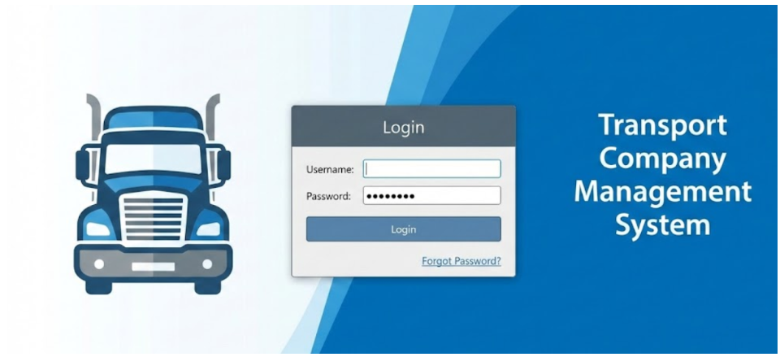
• Inside the app, users will see simple tables with lists of vehicles, routes, and tickets and information about client/available drivers.
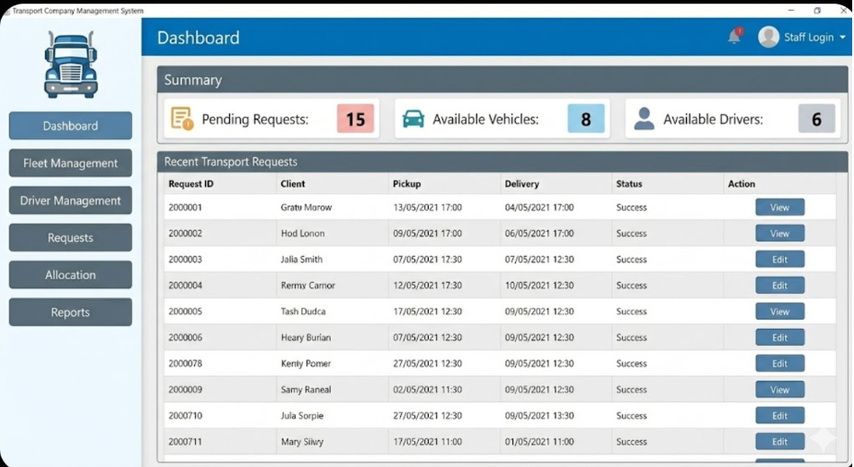
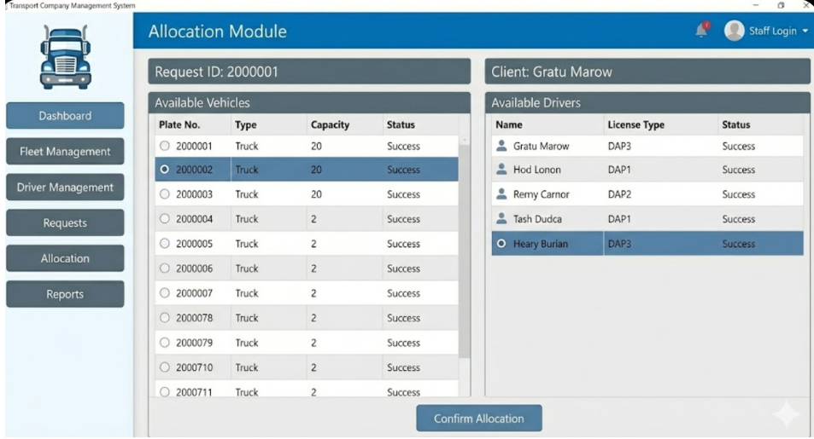

Hardware Interfaces
NOT APPLICABLE.

Software Interfaces
- External Libraries & Frameworks: We use Bootstrap 5 for the frontend to make the user interface responsive and easy to use on any screen. The backend is written in Python (using a framework like Flask or Django) to link the web pages with the database.
- Database Engine: The application uses a local SQLite 3 database. Python connects to it directly using its standard sqlite3 library, which means we do not need to install or configure any complex SQL servers.
- Data Flow & Communications: When a user interacts with the web interface (e.g., clicks a button or submits a form), the browser sends a request to the Python backend. Python processes the request, runs safe SQL commands (like SELECT or INSERT) in the SQLite database, and gets the data back (like vehicle status or user accounts). Finally, Python updates the HTML page to show this data to the user.

Communications Interfaces
The app will use normal internet connections (TCP/IP) to talk to the database server.

System Features

User Authentication
4.1.1 Description and Priority
High Priority. Every user must log in to access the system.
Authorized Users: All user classes (Administrators, Customers, Staff).
4.1.2 Stimulus/Response Sequences
Input: Username and password.
Output: Access response from the server (dashboard access or error message).
4.1.3 Functional Requirements
• REQ-01: The app must have a text box for the username.
• REQ-02: The app must have a text box for the password.
• REQ-03: The app must have a login button.
• REQ-04: The login function must take exactly 2 parameters.
• REQ-05: The system must check the database to see if the user exists.
• REQ-06: The system must block the user after 3 bad passwords.
• REQ-07: The system must show the right screen depending on the user type.
• REQ-08: The app must have a log out button.

Fleet Management
4.2.1 Description and Priority
High Priority. Administrators add and manage vehicle details within the application.
Authorized Users: Administrators only.
4.2.2 Stimulus/Response Sequences
Input: Vehicle details (plate number, capacity, fuel type).
Output: Confirmation of the saved vehicle data in the database.
4.2.3 Functional Requirements
• REQ-09: Admins must choose the vehicle type only from: Truck, Lorrie, Ship, Airplane, or Train.
• REQ-10: The system must save the name or ID of the vehicle.
• REQ-11: The system must save the maximum cargo capacity (in kg or volume) the vehicle has.
• REQ-12: The system must show if the vehicle is free or busy.
• REQ-13: The system must show if the vehicle is broken and needs repairs.
• REQ-14: The system must show the assigned driver or pilot for each vehicle.
• REQ-15: The app must save all the vehicles in a local file.

Driver Management
4.3.1 Description and Priority
High Priority. Administrators manage the database of employed drivers.
Authorized Users: Administrators only.
4.3.2 Stimulus/Response Sequences
Input: Driver details (name, license category, experience).
Output: An updated driver profile in the system.
4.3.3 Functional Requirements
• REQ-16: Administrators will be able to add drivers.
• REQ-17: Administrators will be able to modify drivers.
• REQ-18: Administrators will be able to activate drivers.
• REQ-19: Administrators will be able to deactivate drivers.
• REQ-20: Each driver will have a profile containing personal data.
• REQ-21: Each driver will have a profile containing licenses.
• REQ-22: Each driver will have a profile containing experience.
• REQ-23: Each driver will have a profile containing availability.

Client Portal & Requests
4.4.1 Description and Priority
High Priority. Customers submit detailed transport requests through the interface.
Authorized Users: Customers only.
4.4.2 Stimulus/Response Sequences
Input: Merchandise details, pickup location, delivery location, and dates.
Output: A new pending transport request saved in the system.
4.4.3 Functional Requirements
• REQ-24: Customers will be able to create an account.
- REQ-24.1: The system shall require the customer to input their Date of Birth during account creation.
- REQ-24.2: The system shall prevent users under the age of 13 from creating an account and submitting transport requests.
• REQ-25: Customers will be able to submit transport requests specifying luggage details.
• REQ-26: Customers will be able to submit transport requests specifying weight.
• REQ-27: Customers will be able to submit transport requests specifying volume.
• REQ-28: Customers will be able to submit transport requests specifying pickup locations.
• REQ-29: Customers will be able to submit transport requests specifying delivery locations.
• REQ-30: Customers will be able to submit transport requests specifying preferred dates.
• REQ-31: The system will allow clients to view the status of their submitted requests.

Logistics Notification & Storage
4.5.1 Description and Priority
High Priority. The system stores incoming client requests and alerts the staff.
Authorized Users: Staff (Workers) receive and act upon these notifications.
4.5.2 Stimulus/Response Sequences
Input: New transport request data from the client module.
Output: A visual notification displayed to the logistics staff.
4.5.3 Functional Requirements
• REQ-32: The system will store all incoming requests.
• REQ-33: The system will notify company staff for processing.
• REQ-34: The driver list will be saved in a file in a predetermined format.
• REQ-35: A database server will be configured for storing and managing all information.
• REQ-36: The system shall provide a real-time alert (UI badge) to logistics staff when a new request arrives.
• REQ-37: The system shall log the timestamp of request creation.
• REQ-38: The system shall assign a unique ID to every incoming transport request.
• REQ-39: The system shall encrypt stored passwords in the database.

Allocation Module
4.6.1 Description and Priority
High Priority. Company staff assigns available vehicles and drivers to pending requests.
Authorized Users: Staff (Workers) only.
4.6.2 Stimulus/Response Sequences
Input: Selection of a pending request, an available vehicle, and a driver.
Output: An allocated job record linking the request to the selected resources.
4.6.3 Functional Requirements
• REQ-40: Company staff will be able to allocate a vehicle to each request.
• REQ-41: Company staff will be able to allocate a driver to each request.
• REQ-42: The allocation must be based on availability constraints.
• REQ-43: The allocation must be based on capacity constraints.
• REQ-44: The allocation must be based on route constraints.
• REQ-45: The allocation must be based on scheduling constraints.
• REQ-46: The system shall prevent staff from assigning a vehicle that lacks sufficient capacity.
• REQ-47: The system shall visually distinguish between available and unavailable resources.

Price Offer Generation
4.7.1 Description and Priority
High Priority. The system calculates transportation costs based on logistics variables.
Authorized Users: Staff (Workers) only.
4.7.2 Stimulus/Response Sequences
Input: Allocated job details (route distance, weight, vehicle type).
Output: A generated price offer document sent to the customer.
4.7.3 Functional Requirements
• REQ-48: The system will automatically generate a price offer for each request.
• REQ-49: The price offer will be based on distance.
• REQ-50: The price offer will be based on luggage characteristics.
• REQ-51: The price offer will be based on resource usage.
• REQ-52: The system shall allow staff to override the automatically generated price before sending.
• REQ-53: The system shall attach a validity period to the generated price offer.
• REQ-54: The system shall store the history of generated price offers.
• REQ-55: The system shall ensure the price offer is communicated to the customer.

Customer Offer Workflow
4.8.1 Description and Priority
High Priority. Customers accept or reject the generated price offers.
Authorized Users: Customers (take action) and Staff (view updates/notifications).
4.8.2 Stimulus/Response Sequences
Input: Customer click on the "Accept" or "Reject" button.
Output: Updated request status and an automated alert sent to the staff.
4.8.3 Functional Requirements
• REQ-56: Customers will receive the price offer.
• REQ-57: Customers will be able to accept it through the system.
• REQ-58: Customers will be able to reject it through the system.
• REQ-59: The system shall update the status of the request to "Accepted" if the customer accepts.
• REQ-60: The system shall update the status of the request to "Rejected" if the customer rejects.
• REQ-61: The system shall notify logistics staff of the customer's decision.
• REQ-62: The system shall prevent customers from modifying a request after an offer is generated.
• REQ-63: The system shall cancel offers automatically if not accepted within the validity period.

Job Scheduling & Tracking
4.9.1 Description and Priority
High Priority. The system converts accepted offers into active jobs and blocks resources.
Authorized Users: Staff (Workers) only.
4.9.2 Stimulus/Response Sequences
Input: The "Accepted" status trigger from the customer.
Output: Updated resource availability (vehicle and driver marked as "unavailable").
4.9.3 Functional Requirements
• REQ-64: Once accepted, the system will schedule the transport job.
• REQ-65: The system will track the transport job.
• REQ-66: The system will update the availability of the assigned vehicle.
• REQ-67: The system will update the availability of the assigned driver.
• REQ-68: The system shall allow staff to update the job status (e.g., In Transit, Delivered).
• REQ-69: The system shall mark the vehicle as available again once the job is marked "Delivered".
• REQ-70: The system shall mark the driver as available again once the job is marked "Delivered".
• REQ-71: The system shall log the completion timestamp of the job.

Auditing, Search, and Visualization
4.10.1 Description and Priority
High. Search functionality, data tracking (fingerprints), and visual representation of resources.
Authorized Users: Administrators and Staff (Workers).
4.10.2 Stimulus/Response Sequences
Input: Search keywords or dashboard navigation clicks.
Output: Filtered data grids and graphical maps of the fleet.
4.10.3 Functional Requirements
• REQ-72: The system will allow searching for vehicles, drivers, or transport requests by name, type, status, or date.
• REQ-73: The system shall record the username of the last staff member who modified a transport request, fulfilling the "fingerprint" requirement.
• REQ-74: The system shall record the exact timestamp when the transport request was last modified.
• REQ-75: The system shall record the username of the last staff member who modified a resource assignment (vehicle/driver).
• REQ-76: The system shall assign a specific graphic representation (e.g., a specific icon or image) to each vehicle type.
• REQ-77: The system shall visually link vehicles, drivers, and active jobs using a node-based graph or oriented lines in the UI.
• REQ-78: The system shall display annotations on the oriented lines to describe the exact relationship (e.g., "Assigned to", "Driving").
• REQ-79: The information system will allow graphical visualization of the entire fleet using a color-coded dashboard.
• REQ-80: The information system will allow graphical visualization of driver availability through a timeline or calendar interface.
• REQ-81: The information system will allow graphical visualization of active transport requests using an interactive grid or map module.
• REQ-82: Both the client and the server applications shall provide a simple and intuitive graphical interface for users.

Reporting Module
4.11.1 Description and Priority
Medium Priority. Administrators generate standard usage reports for management.
Authorized Users: Administrators and Staff (Workers).
4.11.2 Stimulus/Response Sequences
Input: Report parameters (date range, resource type) and a "Generate" click.
Output: A viewable and printable PDF/text report document.
4.11.3 Functional Requirements
• REQ-83: The system will allow administrators and company staff to generate reports regarding fleet usage.
• REQ-84: The system will allow administrators and company staff to generate reports regarding driver activity.
• REQ-85: The system will allow administrators and company staff to generate reports regarding completed transport jobs.
• REQ-86: The system shall allow users to export the generated reports to a standard local file format (e.g., CSV or TXT).

Other Nonfunctional Requirements

Performance Requirements
Startup Time: The application GUI must fully load and be ready to use in < 5 seconds.
Concurrency: The database server must successfully process 100 simultaneous user connections without performance degradation.
Response Time: Crucial actions (example: submitting a transport request or generating an offer) must execute in < 2.5 seconds.
Reliability: The system must handle peak loads of 50 queries per second with a 2% crash rate.

Safety Requirements
NOT APPLICABLE.

Security Requirements
• All passwords must be transformed into secret codes (hashed) before saving.
• If a user is not logged in, they cannot see any page or place transport requests.

Software Quality Attributes
- Indentation: The code must use exactly 4 spaces for every indent, without mixing tabs.
- Variables & Functions: Their names must be written in snake_case (like get_price()).
- Classes: Class names must use PascalCase (like TruckManager).
- Constants: Fixed values must be in UPPER_CASE (like MAX_WEIGHT).
- One line, one command: The code must not use semicolons (;) to put multiple commands on the same line.
- Resource Management: Files and databases must be opened using the with statement so they close automatically.
- Imports: All import statements must be placed right at the top of the file.
- No Wildcard Imports: The code must specify exactly what is imported, without using from module import *.
- Comments: Major functions and classes must have a short comment ("""...""") explaining what they do.
- Type Hints: Function parameters must show the expected data type (like user_id: int) to make the code easier to read.
- Float Comparison: Decimal numbers must not be compared using == to avoid math bugs.
- Error Handling: Database queries must be placed inside try-except blocks so the app does not crash if something goes wrong.
- No Silent Fails: An except: block must never be left empty; errors must always be logged or displayed.
- No Recursion: Functions must not call themselves; normal while or for loops must be used instead.
- Clear Returns: Every function that processes data must clearly hit a return statement at the end.
- Security: The eval() and exec() commands must never be used because they are security risks.
- No Globals: The global keyword must be avoided; data should be passed directly through function arguments.
- Safe Loops: Every while loop must have a clear way to stop, to prevent the program from freezing.
- File Names: Python scripts must be saved with simple snake_case names (like main_app.py).
- Safe SQL: Database queries must always use ? placeholders instead of concatenating strings, to prevent SQL injection.

Business Rules
We must respect the GDPR law. This means users can ask us to delete their personal accounts and transport request history, and we must do it to protect their privacy.
Contractual Capacity: To comply with legal contract binding requirements, no customer under the age of 13 is permitted to register or accept price offers within the system.

Other Requirements
NOT APPLICABLE.

Appendix A: Glossary
- TCMS: Transport Company Management System.
- DB: Database.
- GUI: Graphical User Interface.
- Fingerprint: An auditing feature that records the username of the last staff member who modified a transport request or a resource allocation.
- Allocation Module: The company-side application view used by the staff to pair customer requests with available vehicles and drivers.
- GDPR: General Data Protection Regulation.
Appendix B: Analysis Models
- Use Case Diagram: Will illustrate the interaction between the three user classes (Administrators, Customers, Staff) and the system functionalities.

- Entity-Relationship Diagram (ERD): Will detail the database relationships between the main entities (Vehicles, Drivers/Pilots, Transport Requests, User Accounts).

- State-Transition Diagram: Will show the lifecycle of a transport request (from "Pending", to "Offer Generated", "Accepted/Rejected", and finally "Delivered").
Appendix C: To Be Determined List
- TBD-1: The exact format (extension and internal structure, e.g., JSON, XML, or CSV) for the local file where the complete fleet configuration and driver list will be saved.

- TBD-2: The exact mathematical algorithm and weights for the automatic price offer generation (e.g., cost per distance unit, weight/volume multipliers).

- TBD-3: The exact validity period of a price offer before it is automatically canceled by the system.

- TBD-4: The specific C++ graphical library that will be used to implement the GUI and the graphical representations with oriented lines.

